Additional file 1.
Table S1. Functional genomic annotation of detected ORFs in phages proΦ1/proΦ5.
ORF | Start codon | Start | End | Size (aa) | NCBI protein–protein blast similarities with [organism] | Putative function
1 ← | TTG | 1246 | 167 | 359 | Putative integrase [Lactococcus phage µl36]; integrase [Lactococcus phage bIL286] | Integrase
2 ← | ATG | 1946 | 1368 | 192 | Sie_{IL409} [Lactococcus phage 409] ; ORF2 [Lactococcus phage bIL309] | Defense mechanisms (Sie system)
3 ← | ATG | 2866 | 2030 | 278 | Cro/C1-type repressor [Lactococcus phage bIL309]; [Lactococcus phage r1t] | Repressor, transcriptional regulation
4 | ATG | 3083 | 3262 | 59 | Putative transcription regulator [ Lactococcus phage phiLC3 ]; [Lactococcus phage BK5-T] | Transcriptional regulation
5 | ATG | 3283 | 3525 | 80 | Cro/C1-type domain [Lactococcus phage bIL309, Lactococcus phage r1t] | DNA-binding, repressor, transcriptional regulation
6 | ATG | 3538 | 4362 | 274 | BRO-like protein, Prophage antirepressor [Lactococcus lactis subsp. lactis NCDO 2118] | Transcriptional regulation
7 | ATG | 4375 | 4665 | 96 | ORF7 [Lactococcus phage bIL286] | DNA-binding
8 | ATG | 4732 | 4968 | 78 | hypothetical protein ul36_10 [Lactococcus phage µl36]
9 | ATG | 5073 | 5591 | 172 | Bacteriophage Mu Gam like protein [Lactococcus lactis subsp. lactis Dephy 1]. | DNA repair, replication
10 | ATG | 5600 | 6358 | 252 | Phage essential recombination function protein, Erf [Lactococcus lactis subsp. lactis Dephy 1]; putative translation initiation factor [Lactococcus phage µl36] | Recombination
11 | ATG | 6351 | 6776 | 141 | Single-stranded DNA-binding protein [Lactococcus phage bIL286] | DNA recombination and repair
12 | GTG | 6905 | 7687 | 260 | Replication initiation protein [Lactococcus phage Tuc2009] | Replication
13 | ATG | 7687 | 8412 | 241 | Putative topoisomerase [Lactococcus phage Tuc2009] | DNA topology (supercoiling–relaxation, (de)catenation)
14 | ATG | 8409 | 9167 | 252 | Site-specific DNA-methyltransferase (adenine-specific) [Lactococcus phage Tuc2009] | Defense mechanisms (RMS)
15 | ATG | 9142 | 9546 | 134 | Putative RusA resolvase (crossover junction endodeoxyribonuclease) [Lactococcus phage P335] | DNA replication, recombination, and repair
16 | ATG | 9550 | 9744 | 64 | ORF15 [Lactococcus phage r1t]; ORF19 [Lactococcus phage bIL285]
17 | ATG | 9737 | 9976 | 79 | hypothetical protein [Lactococcus phage BK5-T]; unknown [Bacteriophage Tuc2009]; ORF16 [Lactococcus phage r1t]; Mobile element protein [Lactococcus lactis subsp. lactis Dephy 1] | Mobile element protein
18 | ATG | 10088 | 10267 | 59 | hypothetical protein r1tp17 [Lactococcus phage r1t]; hypothetical protein 19 [Lactococcus phage Tuc2009]; unknown [Lactococcus phage µl36A]
19 | ATG | 10257 | 10826 | 189 | hypothetical protein Tuc2009_20 [Lactococcus phage Tuc2009]; ORF23 [Lactococcus phage bIL285]; ORF18 [Lactococcus phage r1t]
20 | ATG | 10837 | 11097 | 86 | hypothetical protein LACR_1789 [Lactococcus lactis subsp. cremoris SK11]
21 | ATG | 11098 | 11304 | 68 | unknown [Lactococcus phage ul36]; ORF25 [Lactococcus phage bIL285]
22 | ATG | 11297 | 11926 | 209 | 65% ORF19 Lactococcus phage TP901-1]; 67% L-asparaginase/archaeal Glu-tRNAGln amidotransferase subunit D [Lactococcus lactis subsp. lactis]
23 | ATG | 11923 | 12342 | 139 | dUTPase/aminotransferase [Lactococcus phage r1t] | dUTPase/aminotransferase
24 | ATG | 12347 | 12616 | 89 | hypothetical protein LGMT14_01283 [Lactococcus garvieae] prophage pi3 protein 34
25 | ATG | 12613 | 12927 | 104 | hypothetical protein P620_05210 [Lactococcus lactis subsp. lactis KLDS 4.0325]
26 | ATG | 12939 | 13328 | 129 | unique hypothetical protein
27 | ATG | 13325 | 13651 | 108 | unique hypothetical protein
28 | ATG | 13648 | 14028 | 126 | unknown [Lactococcus phage phiLC3]; hypothetical protein P620_05220 [Lactococcus lactis subsp. lactis KLDS 4.0325]
29 | ATG | 14047 | 14277 | 76 | rather unique; only hypothetical protein llh_10765 [Lactococcus lactis subsp. cremoris A76]
30 | ATG | 14335 | 14463 | 42 | rather unique; only ORF26 [Lactococcus phage TP901-1]
31 | ATG | 14672 | 14914 | 80 | gp023 [Lactococcus phage KSY1]; hypothetical protein CVCAS_1006 [Lactococcus lactis subsp. lactis CV56]
32 | ATG | 14995 | 15417 | 140 | hypothetical protein Tuc2009_26 [Lactococcus phage Tuc2009]; hypothetical protein µl36_35 [Lactococcus phage ul36]
33 | ATG | 15788 | 16198 | 136 | Phage terminase, small subunit TerS [Lactococcus phage TP901-1]; [Lactococcus phage ul36] | Terminase/endonuclease
34 | ATG | 16191 | 17579 | 462 | Phage terminase, large subunit TerL [Lactococcus phage TP901-1C]; [Lactococcus phage ul36] | Terminase/endonuclease
35 | TTG | 17580 | 18938 | 452 | Portal protein ORF32 [Lactococcus phage TP901-1]; putative portal protein [Lactococcus phage P335] | chromosome packaging
36 | ATG | 18942 | 19982 | 346 | Phage Mu protein F like protein [Lactococcus lactis subsp. cremoris SK11]; putative minor capsid protein [Lactococcus phage P335] | minor capsid protein
37 | ATG | 20028 | 20360 | 110 | hypothetical protein Tuc2009_33 [Lactococcus phage Tuc2009] | head protein
38 | ATG | 20484 | 21146 | 220 | scaffolding protein, putative, SFP [Lactococcus phage TP901-1] | scaffold
39 | ATG | 21148 | 21966 | 272 | major capsid protein MHP [Lactococcus phage TP901-1]; [Lactococcus phage P335] | major capsid protein
40 | GTG | 22026 | 22166 | 46 | hypothetical protein Tuc2009_38 [Lactococcus phage Tuc2009]
41 | ATG | 22150 | 22482 | 110 | unknown [Lactococcus phage P335]; phage gp6-like head-tail connector domain protein [Lactococcus lactis] | head-tail connector
42 | ATG | 22479 | 22790 | 103 | unknown [Lactococcus phage P335]; membrane-associated phospholipid phosphatase [Lactococcus lactis subsp. lactis JCM 5805, dbj|GAM79418.1|] | phospholipid phosphatase
43 | ATG | 22787 | 23113 | 108 | hypothetical protein Tuc2009_41 [Lactococcus phage Tuc2009] | putative tail-component
44 | ATG | 23110 | 23499 | 129 | major structural protein 2 [Lactococcus phage Tuc2009] | capsid and scaffold
45 | ATG | 23510 | 24019 | 169 | major tail protein MTP ORF42 [Lactococcus phage TP901-1] | major tail protein
46 | ATG | 24135 | 24485 | 116 | unknown [Lactococcus phage P335] | putative tape measure chaperone
47 | ATG | 24569 | 24838 | 89 | unknown [Lactococcus phage ul36]; unknown [Lactococcus phage P335]; 72% ORF44 [Lactococcus phage TP901-1] | non-ribosomal peptide synthetase
48 | ATG | 24854 | 25978 | 374 | phage tail length tape-measure protein, partial; most identical to Minor tail protein gp26-like protein [Lactococcus lactis subsp. cremoris SK11] N-terminus | determines the length of the phage tail
49 ← | ATG | 26785 | 26027 | 252 | ATPase AAA [Lactococcus lactis subsp. lactis KLDS 4.0325] | movement of the transposon (transposase/ATPase AAA)
50 ← | ATG | 27981 | 26797 | 394 | integrase [Lactococcus lactis subsp. lactis KLDS 4.0325] | transposase/integrase
51 | ATG | 28088 | 29647 | 519 | C-terminal sequence of tape measure protein TMP ORF45 [Lactococcus phage TP901-1] | determines the length of the phage tail
52 | ATG | 29657 | 30418 | 253 | putative distal tail protein [Lactococcus phage P335]; Chain S, The Structure Of A 1.8 Mda Viral Genome Injection Device Suggests Alternative Infection Mechanisms ORF46 Dit [Lactococcus phage TP901-1] | Tail element, Viral Genome Injection Device pdb|4DIV|T
53 | GTG | 30418 | 33174 | 918 | ORF47 Tal [Lactococcus phage TP901-1]; peptidase M23 [Lactococcus lactis]; putative tail associated lysin [Lactococcus phage P335] | Tail fiber; Peptidase (family M23/M37)
54 | ATG | 33187 | 34167 | 326 | structural protein [Lactococcus phage ul36]; SAM-dependent methyltransferases [JCM 5805 Lactococcus lactis subsp. lactis]; ORF48 BppU [Lactococcus phage TP901-1] | upper base plate protein
55 | ATG | 34157 | 34942 | 261 | putative base plate protein [Lactococcus phage P335]; signal transduction histidine kinase [JCM 5805 Lactococcus lactis subsp. lactis] | signalling, tail, host specificity
56 | ATG | 34961 | 35452 | 163 | Baseplate Tripod, BPP [Lactococcus phage ORF49 BppLTP901-1] | Lower base plate, Receptor Binding
57 | ATG | 35466 | 35690 | 74 | holin, ORF58 [Lactococcus phage bIL286] | permeabilization of the membrane
58 | ATG | 35703 | 38066 | 787 | putative neck passage structure ORF59 [Lactococcus phage bIL286] | neck passage
59 | ATG | 38091 | 38357 | 88 | holin, LysA [Lactococcus phage phiLC3] | permeabilization of the membrane
60 | ATG | 38354 | 39643 | 429 | lysin, LysB [Lactococcus phage phiLC3] | degrading the cell wall
61 | TTG | 39879 | 40838 | 319 | Abi-like protein, CAAX protease [Streptococcus thermophilus TH1477] | Defense mechanisms (Abi-system)
62 | TTG | 41110 | 41247 | 45 | prophage pi3 protein 03 [Lactococcus lactis subsp. lactis Il1403] DNA methylase N-4/N-6|Restriction/modification DNA-methylase | Defense mechanisms (RMS)

Table S2. Functional genomic annotation of detected ORFs in phages proΦ2/proΦ4.
ORF | Start codon | Start | End | Size (aa) | NCBI protein–protein blast similarities with [organism] | Putative function
1 ← | ATG | 1275 | 136 | 379 | Phage integrase [Lactococcus lactis subsp. lactis Dephy 1] | Integrase
2 ← | ATG | 2140 | 1325 | 271 | repressor CI/C2 family [Lactococcus lactis subsp. cremoris HP] 79%, C-terminus | Repressor, transcriptional regulation
3 | ATG | 2403 | 2651 | 82 | Cro/Cl family transcriptional regulator [Lactococcus lactis subsp. lactis KLDS 4.0325] | Transcriptional regulation
4 | ATG | 2664 | 3407 | 247 | Phage antirepressor protein, ORF6 [Lactococcus phage TP901-1] | Transcriptional regulation
5 | ATG | 3421 | 3759 | 112 | hypothetical protein P620_08995 [Lactococcus lactis subsp. lactis KLDS 4.0325]
6 | ATG | 3911 | 4117 | 68 | putative DNA-binding protein [Lactococcus lactis subsp. lactis Dephy 1]; [Lactococcus lactis subsp. lactis JCM 5805]
7 ← | TTG | 4487 | 4110 | 125 | putative DNA-binding protein [Lactococcus lactis subsp. lactis JCM 5805] | Transcriptional regulation
8 | ATG | 4592 | 4807 | 73 | ORF11 [Lactococcus phage bIL286]; predicted outer membrane protein [Lactococcus lactis subsp. Lactis JCM 5805]
9 | ATG | 4928 | 5446 | 172 | Bacteriophage Mu Gam like protein, ORF14 [Lactococcus phage TP712]
10 | ATG | 5455 | 6174 | 239 | phage nucleotide-binding protein [Lactococcus phage TP712]
11 | ATG | 6174 | 6677 | 167 | single-stranded DNA-binding protein SSB [Lactococcus phage TP712]
12 | GTG | 6811 | 7593 | 260 | replication initiation protein [Bacteriophage Tuc2009]
13 | ATG | 7593 | 8318 | 241 | putative topoisomerase [Lactococcus phage Tuc2009]
14 | ATG | 8315 | 9073 | 252 | Adenine-specific methyltransferase [Lactococcus phage Tuc2009] | Defense mechanisms
15 | TTG | 9063 | 9452 | 129 | crossover junction endodeoxyribonuclease RusA [Lactococcus phage P335]
16 | ATG | 9456 | 9695 | 79 | hypothetical protein Tuc2009_18 [Lactococcus phage Tuc2009]; Mobile element protein [Lactococcus lactis subsp. lactis Dephy 1]
17 | ATG | 9711 | 10019 | 102 | unknown [Lactococcus phage P335]
18 | GTG | 10185 | 10298 | 37 | unknown [Lactococcus phage P335]
19 | ATG | 10288 | 10866 | 192 | ORF23 [Lactococcus phage bIL285]
20 | ATG | 10877 | 11272 | 131 | unknown [Lactococcus phage P335]; predicted metal-dependent hydrolase [Lactococcus lactis subsp. Lactis JCM 5805]
21 | ATG | 11265 | 11837 | 190 | unknown [Lactococcus phage phiLC3]
22 | ATG | 11834 | 12253 | 139 | dUTPase [Lactococcus phage phiLC3]
23 | ATG | 12258 | 12602 | 114 | prophage protein [Lactococcus lactis subsp. lactis CV56]; mismatch repair ATPase C-term. [Lactococcus lactis subsp. Lactis JCM 5805]
24 | ATG | 12599 | 12850 | 83 | conserved hypothetical protein [Lactococcus lactis subsp. lactis CV56]
25 | ATG | 12840 | 13034 | 64 | hypothetical protein ul36_26 [Lactococcus phage ul36]
26 | ATG | 13061 | 13246 | 61 | hypothetical protein P335p27 [Lactococcus phage P335 sensu lato] | DNA-binding
27 | ATG | 13328 | 13750 | 140 | ORF36 [Lactococcus phage bIL309]; activator of late transcription ALT [Lactococcus phage TP901-1] | Activation of late transcription
28 | ATG | 14000 | 14557 | 185 | Homing HNH homing endonucleases [Lactococcus phage BK5-T]
29 | ATG | 14685 | 15158 | 157 | putative small terminase subunit [Lactococcus phage BK5-T]
30 | ATG | 15148 | 17118 | 656 | putative large terminase subunit [Lactococcus phage BK5-T] | putative large terminase subunit
31 | ATG | 17090 | 17305 | 71 | hypothetical protein P335p32 [Lactococcus phage P335 sensu lato] | head-tail joining protein
32 | TTG | 17308 | 18480 | 390 | putative portal protein [Lactococcus phage BK5-T] | portal protein
33 | ATG | 18526 | 19230 | 234 | putative ClpP protease [Lactococcus phage P335 sensu lato] | ATP-dependent serine endopeptidase
34 | ATG | 19242 | 20456 | 404 | major structural protein [Lactococcus phage BK5-T] | Phage capsid protein
35 | ATG | 20464 | 20778 | 104 | hypothetical protein [Lactococcus phage BK5-T]; Phage DNA packaging [Lactococcus lactis subsp. lactis Dephy 1] | Phage DNA packaging
36 | ATG | 20762 | 21112 | 116 | Phage head-tail joining protein [Lactococcus lactis subsp. lactis Dephy 1]; ORF47 [Lactococcus phage bIL286] | head-tail joining protein
37 | ATG | 21114 | 21620 | 168 | Phage tail protein ORF48 [Lactococcus phage bIL286] | head-tail adapter protein
38 | ATG | 21617 | 22012 | 131 | ORF49 [Lactococcus phage bIL286] | tail component
39 | ATG | 22043 | 22636 | 197 | ORF50 [Lactococcus phage bIL286]; major structural protein [Lactococcus phage BK5-T] | major tail protein
40 | ATG | 22781 | 23197 | 138 | Phage tail assembly [Lactococcus lactis subsp. lactis Dephy 1] | tail assembly
41 | ATG | 23422 | 28344 | 1640 | tail protein ORF52 [Lactococcus phage bIL286] | phage tail tape measure protein
42 | ATG | 28347 | 29882 | 511 | ORF53 [Lactococcus phage bIL286] | Phage tail fiber
43 | ATG | 29882 | 31669 | 595 | ORF54 [Lactococcus phage bIL286] | tail-host specificity, receptor binding
44 | ATG | 31685 | 32806 | 373 | ORF55 [Lactococcus phage bIL286] | putative tail fiber
45 | ATG | 32806 | 32979 | 57 | helicase subunit of the DNA excision repair complex [Lactococcus lactis subsp. Lactis JCM 5805]; ORF56 [Lactococcus phage bIL286]
46 | ATG | 32957 | 35209 | 750 | host-specificity [Lactococcus phage bIL286] | putative receptor binding protein
47 | ATG | 35229 | 35555 | 108 | ORF54 [Lactococcus phage bIL309]
48 | ATG | 35542 | 35829 | 95 | holin [Lactococcus phage bIL309]
49 | ATG | 35829 | 36608 | 259 | lysin [Lactococcus phage bIL309]

Table S3. Functional genomic annotation of detected ORFs in phage proΦ6.
ORF | Start codon | Start | End | Size (aa) | NCBI protein–protein blast similarities with [organism] | Putative function
1 ← | ATG | 1209 | 85 | 374 | Integrase [Lactococcus phage r1t]
2 ← | ATG | 1910 | 1329 | 193 | prophage pi3 protein 59 [Lactococcus lactis subsp. lactis]
3 ← | ATG | 2861 | 1971 | 296 | cI repressor [Lactococcus phage BK5-T]
4 | ATG | 3339 | 3587 | 82 | Cro/Cl family transcriptional regulator [Lactococcus phage BK5-T]
5 | ATG | 3599 | 4345 | 248 | AntA/AntB antirepressor [Lactococcus lactis subsp. lactis KLDS 4.0325]
6 | ATG | 4358 | 4690 | 110 | hypothetical protein Tuc2009_06 [Lactococcus phage Tuc2009]
7 | ATG | 4692 | 4931 | 79 | unknown [Lactococcus phage BK5-T]
8 | ATG | 5031 | 5549 | 172 | unknown [Lactococcus phage TP712] | bacteriophage Mu Gam-like protein
9 | ATG | 5558 | 6181 | 207 | ORF11 [Lactococcus phage TP901-1] | topoisomerase
10 | ATG | 6181 | 6633 | 150 | SSB [Lactococcus phage TP901-1] | single stranded binding protein
11 | ATG | 6654 | 7151 | 165 | homing nuclease [Lactococcus lactis subsp. lactis bv. diacetylactis str. LD61]
12 | GTG | 7318 | 8064 | 248 | DNA replication protein [Lactococcus lactis subsp. lactis KLDS 4.0325]
13 | ATG | 8074 | 8964 | 296 | putative replication protein DnaC [Lactococcus phage r1t] | prepilin peptidase
14 | ATG | 8974 | 9138 | 54 | unknown [Lactococcus phage TP712]
15 | GTG | 9128 | 9517 | 129 | RusA [Lactococcus phage bIL285] | crossover junction endodeoxyribonuclease RusA
16 | ATG | 9521 | 9760 | 79 | unknown [Bacteriophage Tuc2009]
17 | ATG | 9872 | 10048 | 58 | hypothetical protein r1tp17 [Lactococcus phage r1t]
18 | ATG | 10041 | 10634 | 197 | unknown [Lactococcus phage phiLC3]
19 | ATG | 10645 | 11034 | 129 | unknown [Bacteriophage Tuc2009]
20 | ATG | 11031 | 11237 | 68 | ORF18 [Lactococcus phage TP901-1]
21 | ATG | 11230 | 11760 | 176 | putative phage related protein [Lactococcus lactis subsp. cremoris GE214]
22 | ATG | 11757 | 11921 | 54 | hypothetical protein BN927_02086 [Lactococcus lactis subsp. lactis Dephy 1]
23 | ATG | 11918 | 12337 | 139 | dUTPase [Lactococcus phage bIL286] | aminotransferase
24 | ATG | 12356 | 12901 | 181 | putative HNH endonuclease [Lactococcus phage P335]
25 | ATG | 12888 | 13568 | 226 | hypothetical protein r1tp22 [Lactococcus phage r1t] | methylase
26 | ATG | 13598 | 13993 | 131 | hypothetical protein [Lactococcus lactis subsp. cremoris A76]
27 | ATG | 14092 | 14514 | 140 | putative transcriptional regulator [Lactococcus phage P335]; ALT [Lactococcus phage TP901-1] | activator of late transcription
28 | ATG | 15075 | 15707 | 210 | chromosome partitioning protein ParB, partial [Lactococcus garvieae]
29 | ATG | 15757 | 16314 | 185 | hypothetical protein [Lactococcus garvieae I113]
30 | ATG | 16342 | 16854 | 170 | Terminase small subunit [Lactococcus garvieae I113]
31 | ATG | 16844 | 18064 | 406 | Phage terminase large subunit [Lactococcus garvieae I113]
32 | TTG | 18065 | 19423 | 452 | Portal_protein ORF32 [Lactococcus phage TP901-1] | portal protein
33 | ATG | 19427 | 20467 | 346 | putative minor capsid protein [Lactococcus phage ul36.k1] Phage Mu protein F like protein
34 | ATG | 20513 | 20845 | 110 | hypothetical protein Tuc2009_33 [Lactococcus phage Tuc2009] | head protein
35 | ATG | 20969 | 21631 | 220 | scaffolding protein SFP [Lactococcus phage TP901-1]
36 | ATG | 21633 | 22454 | 273 | major capsid protein [Lactococcus phage P335]
37 | GTG | 22514 | 22654 | 46 | hypothetical protein Tuc2009_38 [Lactococcus phage Tuc2009]
38 | ATG | 22638 | 22970 | 110 | unknown [Lactococcus phage P335] | phage gp6-like head-tail connector domain protein
39 | TTG | 22967 | 23227 | 86 | hypothetical protein Tuc2009_40 [Lactococcus phage Tuc2009] | Phage head-tail joining protein
40 ← | ATG | 24099 | 23209 | 296 | transposase [Lactococcus lactis subsp. cremoris strain A17]
41 | ATG | 24166 | 24285 | 39 | Disrupted by the transposase. Originally ORF39+41
42 | ATG | 24282 | 24608 | 108 | putative structural protein [Lactococcus phage ul36.k1]
43 | ATG | 24605 | 25000 | 131 | conserved hypothetical protein [Lactococcus lactis subsp. lactis CV56]. | phage capsid and scaffold protein
44 | ATG | 25011 | 25508 | 165 | major tail protein [Lactococcus phage ul36]
45 | ATG | 25624 | 25974 | 116 | unknown [Lactococcus phage P335] | Tape measure chaperone
46 | ATG | 26058 | 26327 | 89 | unknown [Lactococcus phage ul36]
47 | ATG | 26343 | 28556 | 737 | putative tape-measure protein [Lactococcus phage ul36]
48 | ATG | 28566 | 29327 | 253 | putative distal tail protein [Lactococcus phage P335]
49 | GTG | 29327 | 32212 | 961 | membrane proteins related to metalloendopeptidases [Lactococcus lactis subsp. lactis]
50 | ATG | 32225 | 34750 | 841 | baseplate/receptor binding protein [Lactococcus phage 98202]
51 | ATG | 34797 | 35105 | 102 | unknown [Lactococcus phage ul36] | transposase
52 | ATG | 35089 | 35316 | 75 | Holin [Lactococcus phage r1t]
53 | ATG | 35317 | 36129 | 270 | Lysin [Lactococcus phage r1t]
54 | ATG | 36388 | 36609 | 73 | DNA internalization-related competence protein ComEC/Rec2 [Enterobacteriaceae bacterium strain FGI 57]
55 | ATG | 36575 | 37060 | 161 | Hypothetical protein, phage associated [Lactobacillus phage Sal2]

Table S4. Functional genomic annotation of detected ORFs in phage proΦ7.
ORF | Start codon | Start | End | Size (aa) | NCBI protein–protein blast similarities with [organism] | Putative function
1 ← | ATG | 1364 | 225 | 379 | Phage integrase [Lactococcus lactis subsp. cremoris A76]
2 ← | ATG | 2065 | 1484 | 193 | prophage pi3 protein 59 [Lactococcus lactis subsp. lactis]
3 ← | ATG | 2715 | 2128 | 195 | ORF4 [Lactococcus phage bIL312]
4 ← | ATG | 3096 | 2728 | 122 | repressor [Lactococcus phage bIL312] | XRE family transcriptional regulator
5 | ATG | 3391 | 3582 | 63 | ORF6 [Lactococcus phage bIL312] | antirepressor
6 | ATG | 3598 | 3858 | 86 | excisionase [Lactococcus phage bIL312]; Glycogen phosphorylase [Lactococcus lactis subsp. cremoris A76]
7 | ATG | 4014 | 4184 | 56 | unknown [Lactococcus phage TPW22]
8 | ATG | 4184 | 4621 | 145 | hypothetical protein N489_12525 [Lactococcus lactis subsp. lactis 1AA59]
9 | ATG | 4736 | 5086 | 116 | unknown [Lactococcus phage TPW22]
10 | ATG | 5103 | 5621 | 172 | DNA-binding protein [Lactococcus lactis subsp. lactis 1AA59]
11 | ATG | 5632 | 6336 | 234 | DEAD/DEAH box helicase [Lactococcus phage phi31]
12 | ATG | 6323 | 7669 | 448 | hypothetical protein [Lactococcus phage phi31]
13 | ATG | 7687 | 8139 | 150 | hypothetical protein [Lactococcus phage phi31]
14 | ATG | 8154 | 8948 | 264 | hypothetical protein [Lactococcus phage phi31] | bifunctional DNA primase/polymerase
15 | ATG | 8923 | 10386 | 487 | putative primase [Lactococcus phage phi31]
16 ← | ATG | 10462 | 10349 | 37 | C terminus putative primase [Lactococcus phage phi31]
17 | ATG | 10610 | 10921 | 103 | hypothetical protein U725_00824 [Lactococcus lactis subsp. cremoris GE214]; hypothetical protein [Lactococcus phage phi31]
18 | ATG | 11050 | 11289 | 79 | unknown [Lactococcus phage TP712]
19 | ATG | 11398 | 11574 | 58 | ORF22 [Lactococcus phage bIL285]
20 | ATG | 11567 | 12160 | 197 | hypothetical protein phiLC3p17 [Lactococcus phage phiLC3]
21 | ATG | 12171 | 12566 | 131 | hypothetical protein Tuc2009_21 [Lactococcus phage Tuc2009]
22 | ATG | 12559 | 13143 | 194 | L-asparaginase/archaeal Glu-tRNAGln amidotransferase subunit D [Lactococcus lactis subsp. Lactis JCM 5805]; 60% unknown [Bacteriophage Tuc2009]
23 | ATG | 13140 | 13559 | 139 | dUTPase DUT [Lactococcus phage TP712] | aminotransferase
24 | GTG | 13560 | 13898 | 112 | unknown [Lactococcus phage phiLC3]
25 | ATG | 14041 | 14184 | 47 | ORF28 [Lactococcus phage TP901-1]
26 | ATG | 14265 | 14696 | 143 | putative transcriptional activator [Lactococcus phage phiLC3]; transcriptional activator of phage 31 late promoter [Lactococcus phage phi31] | transcriptional activator of phage 31 late promoter
27 ← | TTG | 14994 | 14701 | 97 | N term. hypothetical protein r1tp26, partial [Lactococcus phage r1t] | HNH homing endonuclease
28 | ATG | 15014 | 15154 | 46 | C term. ORF26 [Lactococcus phage r1t]
29 | TTG | 15301 | 16530 | 409 | ORF5 [Lactococcus phage phi31]; putative portal protein [Lactococcus lactis subsp. cremoris GE214] | portal protein
30 | ATG | 16530 | 17294 | 254 | ORF28 [Lactococcus phage r1t]
31 | ATG | 17345 | 18754 | 469 | terminase ORF29 [Lactococcus phage r1t]
32 | ATG | 18827 | 19291 | 154 | ORF30 [Lactococcus phage r1t]; putative scaffolding protein [Lactococcus phage phiLC3]
33 | ATG | 19295 | 20191 | 298 | major head protein [Lactococcus phage phiLC3]; Structural protein [Lactococcus phage r1t]
34 | ATG | 20206 | 20505 | 99 | ORF32 [Lactococcus phage r1t]; unknown [Lactococcus phage phiLC3]
35 | ATG | 20507 | 20905 | 132 | ORF33 [Lactococcus phage r1t]; unknown [Lactococcus phage phiLC3]
36 | ATG | 20892 | 21230 | 112 | ORF34 [Lactococcus phage r1t]
37 | ATG | 21223 | 21459 | 78 | ORF35 [Lactococcus phage r1t]; unknown [Lactococcus phage phiLC3]
38 | ATG | 21460 | 21795 | 111 | unknown [Lactococcus phage phiLC3]; ORF36 [Lactococcus phage r1t]
39 | ATG | 21806 | 22363 | 185 | major tail protein [Lactococcus phage phiLC3]; Structural protein [Lactococcus phage r1t]
40 | ATG | 22406 | 22666 | 86 | ORF38 [Lactococcus phage r1t]; unknown [Lactococcus phage phiLC3]
41 ← | ATG | 23672 | 22914 | 252 | unknown [Lactococcus phage TP712] | transposase helper protein; IstB helper protein
42 ← | ATG | 24868 | 23684 | 394 | MULTISPECIES: integrase [Bacilli]; unknown [Lactococcus phage TP712] | integrase/tranposase
43 | ATG | 24989 | 25240 | 83 | ORF39 [Lactococcus phage r1t]
44 | ATG | 25225 | 25833 | 202 | ORF40 [Lactococcus phage r1t]; putative tape measure protein [Lactococcus phage phiLC3]
45 | ATG | 25934 | 26494 | 186 | endodeoxyribonuclease [Streptococcus pyogenes]; putative endodeoxyribonuclease ORF41 [Lactococcus phage r1t] | HNH endonuclease
46 | ATG | 26702 | 28675 | 657 | putative tape measure protein [Lactococcus phage phiLC3]
47 | ATG | 28691 | 29584 | 297 | hypothetical protein phiLC3p42 [Lactococcus phage phiLC3]; ORF43 [Lactococcus phage r1t] | tail protein
48 | ATG | 29589 | 30749 | 386 | hypothetical protein phiLC3p43 [Lactococcus phage phiLC3]; ORF44 [Lactococcus phage r1t] | tail structural protein
49 | ATG | 30746 | 31807 | 353 | putative baseplate protein [Lactococcus phage phiLC3] | baseplate protein
50 | ATG | 31823 | 32248 | 141 | putative receptor binding protein [Lactococcus phage 1727] | receptor binding protein
51 | ATG | 32295 | 32519 | 74 | holin ORF58 [Lactococcus phage bIL286] | holin
52 | ATG | 32531 | 34159 | 542 | putative neck passage structure [Lactococcus phage phiLC3] | neck passage
53 | ATG | 34184 | 34408 | 74 | holin, Dp-1 family [Lactococcus lactis subsp. cremoris SK11]; putative holin [Lactococcus phage ul36] | holin
54 | ATG | 34405 | 35694 | 429 | lysin [Lactococcus phage TPW22] | lysin, 1,4-beta-N-acetylmuramidase
55 | ATG | 35882 | 37114 | 410 | 49% abortive phage resistance protein [Lactobacillus salivarius]; 49% abortive phage resistance protein [Streptococcus oralis] | abortive phage resistance protein
56 | ATG | 37116 | 37694 | 192 | 40% RloB-like protein [Streptococcus oralis SK610]; 36% abortive phage resistance protein [Streptococcus parasanguinis] | abortive phage resistance protein

Table S5. Bacteriophages used in phage sensitivity screen.
Phage/code | Relevant features | Source or reference
sk1 | 936-type lytic isometric-headed phage | Chandry et al., 1997
jj50 | 936-type lytic isometric-headed phage | Josephsen et al., 1989
p2 | 936-type lytic isometric-headed phage | Higgins et al., 1988
ΦT1 | P335-type temperate phage | =ΦTIFN1 in Erkus et al., 2013
ΦT5 | 936-type lytic | =ΦTIFN5 in Erkus et al., 2013
ΦT7 | P335-type temperate phage | =ΦTIFN7 in Erkus et al., 2013
DSMΦ1 | c2-type lytic | DSM Food Specialities B.V.
DSMΦ2 | c2-type lytic | DSM Food Specialities B.V.
DSMΦ3 | P335-type temperate phage | DSM Food Specialities B.V.
DSMΦ4 | 936-type lytic | DSM Food Specialities B.V.
DSMΦ5 | 936-type lytic | DSM Food Specialities B.V.
DSMΦ6 | 936-type lytic | DSM Food Specialities B.V.
DSMΦ7 | 936-type lytic | DSM Food Specialities B.V.
DSMΦ8 | not typed | DSM Food Specialities B.V.
DSMΦ9 | not typed | DSM Food Specialities B.V.
DSMΦ10 | c2-type lytic | DSM Food Specialities B.V.

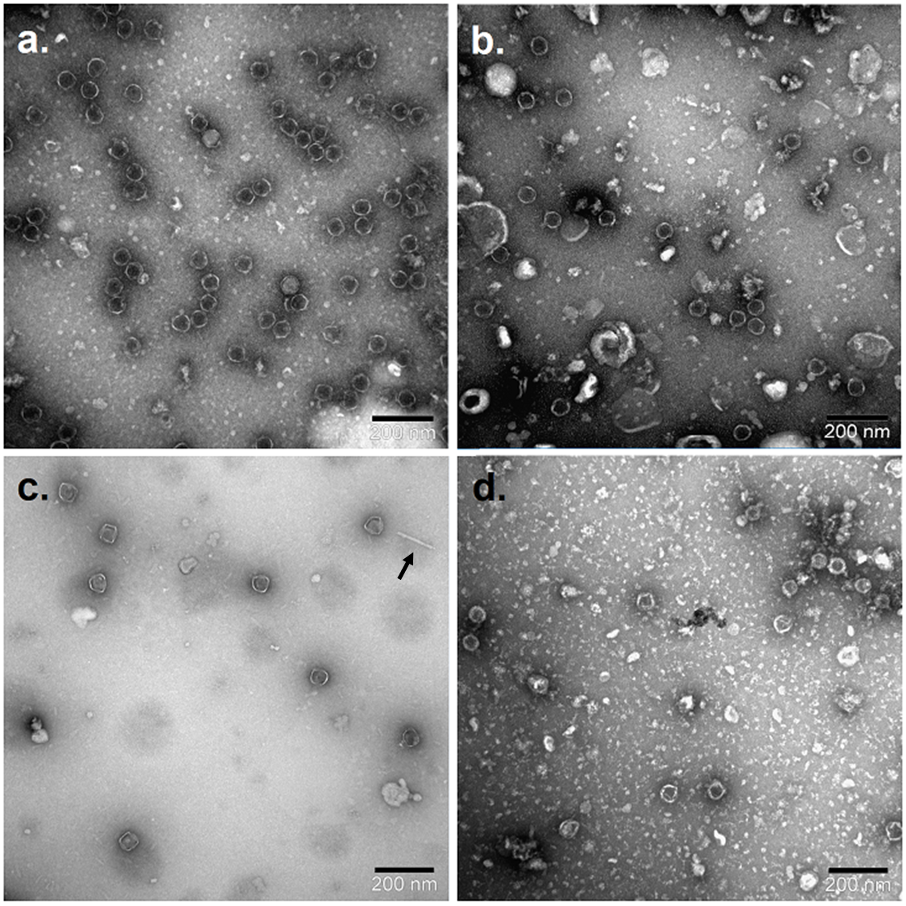
Figure S1. Transmission electron microscopic (TEM) pictures of Ur phages. a) proΦ1; b) proΦ2; c) proΦ6, arrow shows a phage tail separated from the head; d) proΦ7. Samples for proΦ1, proΦ6 and proΦ7 were treated with chloroform before TEM imaging, the sample for proΦ2 was not treated with chloroform.

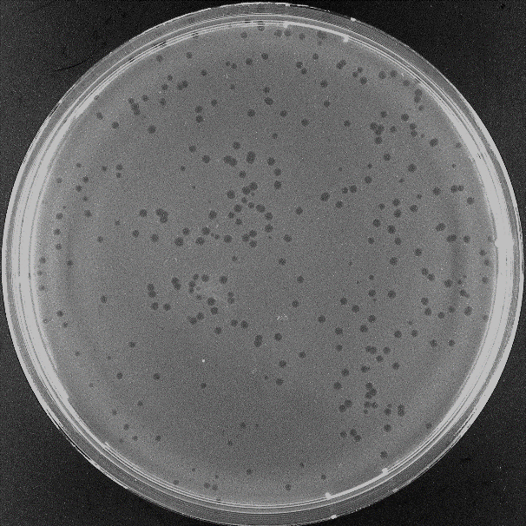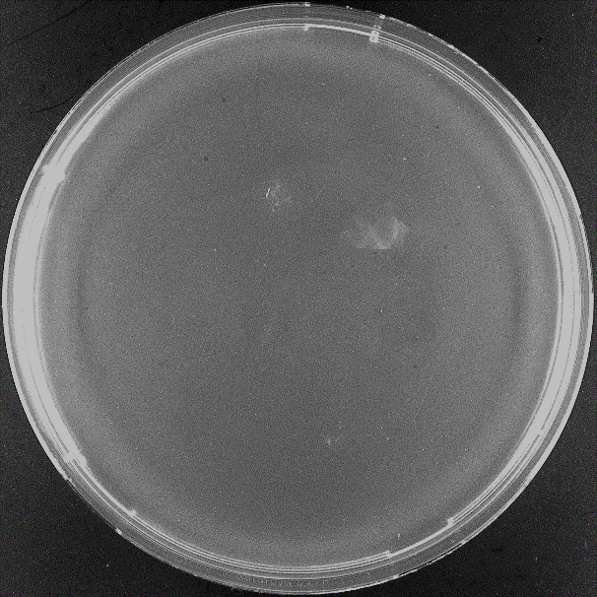
Figure S2. Example of plaque morphology on TIFN1 and TI1c. DSMΦ4 plaque appearance on the lawns of A. WT TIFN1, B. cured TI1c.
A
B

